**A**

**PROJECT REPORT**

**ON**

**“ONLINE CAR SHOWROOM”**

**ACADAMIC YEAR OCT 2020-21**

**B.C.A (5th SEM)**

**SUBMITTED TO**

**SAURASHTRA UNIVERSITY,**

**RAJKOT**



**COLLEGE NAME**

**BHAVAN’S SHREE H.J. DOSHI, INFORMATION**

**TECHNOLOGY INSTITUTE,**

**JAMNAGAR**

**SUBMITTED BY :-**

**JEET MEHTA**

**YASH MEHTA**

**UNDER THE GUIDENCE OF:-**

**HIRAL PANDYA**

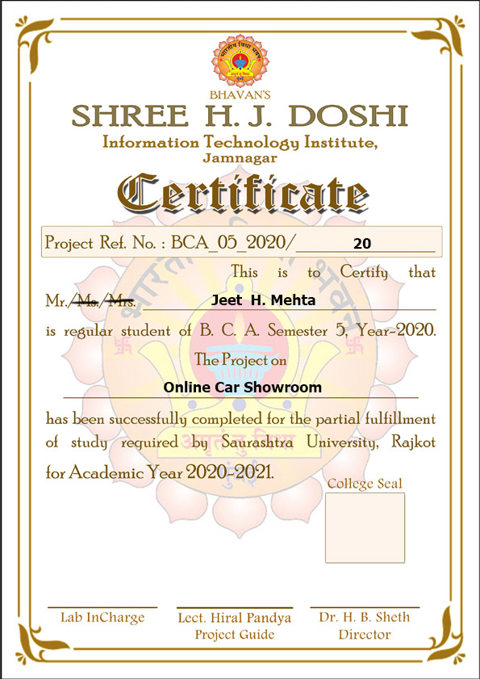

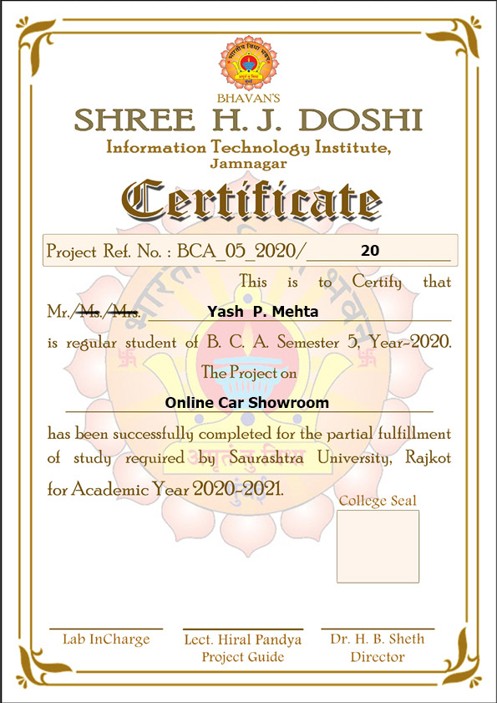

|  |  |  |
| --- | --- | --- |
| NO | TITLE | PAGE NO |
| 1 | **ABSTRACT** | **05-06** |
| 2 | **PROFILE** | **07** |
| 3 | **INTRODUCTION**     |  | | --- | | * **Project Summary** * **Project Purpose** * **Project Scope** | |  | | **08** |
| 4 | **SYSTEM ANALYSIS**   * **Study of Current System** * **Problem and Weakness of Current System** * **Feasibility Study** | **09-11** |
| 5 | **SYSTEM DESIGN**   |  | | --- | | * **Data Flow Dia**  **gram** * **E-R Diagram** * **Data Dictonary** | | **12-20** |
| 6 | **IMPLEMENTATION AND TESTING** | **21** |
| 7 | **SCREENSHOTS&USER MANUAL** | **22-32** |
| 8 | **LIMITATION AND FUTURE ENHANCEMENT** | **33** |
| 9 | **BIBLIOGRAPHY** | **34** |

INDEX

ABSTRACT

* **PROJECT TITLE:**

**“ONLINE CAR SHOWROOM”**

* **AIM OF PROJECT:**

Project making is a part of BCA. The student gets a chance to have practical knowledge of the software exposure as to gain control over programming languages. The objective of practical training of BCA levels is to develop among the student a feeling of software making in order to develop a practical base in them as supplement to the theoretical study of the computer application in general.

Such project making plays a domain role in developing practical viewpoints, experiences and also make them aware about the role situation of the software application.

This project is prepared under my knowledge, guidance given by our professors and specially thanks to concerned person, who has helped us to get knowledge on the project.

* **PROJECT CATEGORY:**

Web Application

* **PROJECT DESCRIPTION:**

The objective of this project is to maintain the details of the purchasing and selling of CARS**.**

The main objective of this project is to improve the administrator efficiency facilitating it to promptly address any kind of information sought for and to minimize the workload.

DECLARATION

Jeet Mehta and Yash Mehta student of 5th semester of BCA (Bachelor of Computer Application) at **SHREE H.J. DOSHI I.T. INSTITUTE** Jamnagar declares against you that this web site is developed by us.

No serious and lasting achievement or success, one can ever achieve without the help of friendly guidance and co-operation of all people involved in this work.

First of all we are grateful **Prof. Hiral Pandya** for helping us so much and showing his keen interest and co-operation in completing this work. Then we would like to thank my lab faculties also for co-ordination.

We would also like to thanks my Parents, friends and all member of my family for encouraging me for this work.

Thanks from,

JEET MEHTA.

YASH MEHTA.

Date:

Place:Jamnagar

PROFILE

**Project Name**  : - Online car showroom

**Project Language** : - Front_End : PHP

Back_End : MYSQL (Database)

**Year**  : - 2020-21

**Duration**  : - 3 Months

**Software** **Requirements** : - MySQL

Web server

PHP

INTRODUCTION

* **Project Summary:-**

The project ONLINE CAR SHOWROOM is a web based project. It is totally based on the buying and selling of the cars.

Customer can see each and every detail of his/her car on this website. From adding a car to the cart till buying it and then sharing a feedback is a part of this project.

Now a days people are totally dependent on online shopping because no one has time to go to the shop and buy it manually. So it is a helpful project in sense of time and cost.

* **Purpose of Project:-**

In this site, user can see the various models of cars, prices, showrooms, relevant information etc. So user has not to go for different showrooms to search for their car. He/she can easily book their car through this site and can get it on his prescribed time.

All the entry fills up by the user, so user can get all the details of his/her car. After that the details can be notified by email or contact numbers.

The Website is developed in PHP, HTML, Java Script and MySQL for the Database.

The Website maintains the data of the user and its purchased car.

* Scope of Project:-

Our main aim is to perform all the transactions in a system. It is well organized, in order to reduce the cost and time of the user and equally maintain it as user-friendly.

SYSTEM ANALYSIS

* STUDY OF CURRENT SYSTEM:-

We have found that many problems had arised in old system. So me and my partner decided to make new project with many facilities.

The investigation is needed to prepare a new system of computerization.

This project contains the information related to the user.

To build this project some investigation has been done. A number of weakness in the current system has been stated. This are described below:-

* Objectives need the new system.
* Problem and weakness in the current system.
* Method to store the records in the manual system.
* It is time consuming.
* Information must be kept for each user.
* The possible output of the records.
* PROBLEM & WEAKNESS OF CURRENT SYSTEM:-

Every system faces different types of problems and after knowing various weaknesses we can be able to do the work in a best way

The problems and weakness of our site are as follows :-

* People have financial issues while buying this type of products.
* There are no offers for the booking of cars.
* The user can’t check the live tracking of the car when it will be approved.

Feasibility Study

Feasibility study of the system is a very important stage during system design. Feasibility study is a test of a system proposal according to its workability impact on the organization, ability to meet user needs, and effective use of resources. Feasibility study decides whether the system is properly developed or not.

Following aspects are taken into account during feasibility study.

* **Technical Feasibility:-**

Technical feasibility that means user can store data in 4GB memory expand in the Pc. User can access Windows10 OS.

* **Software Requirement:-**

Developer can run this website in Chrome, Explorer and Firefox.

We had developed this project in PHP and MYSQL.

* **Network Requirement:-**

Internet is the main requirement to develop any project.

* **Economic Feasibility:**

|  |  |  |
| --- | --- | --- |
| **Hard Disk Drives** | 360 GB | 1295 RS. |
| **RAM** | 4 GB | 2960 RS. |
| **Processor** | 4 GB | 5999 RS. |
| **Window** | 64 Ultimate | 5480 RS. |
| **CPU** | Intel i3 7020U | @ 2.30GHZ |

* **Operational Feasibility:**

Software will be user friendly and easy to access operation.

DFD (Data Flow Diagram)

The DFD (Data Flow diagram) is a graphical representation of ‘flow’ of data through on information system, modeling its process aspects. A DFD is often used as a preliminary step to create and overview of system, which can later be elaborated. DFD can also be used for visualization of data processing.

A DFD shows what kind of information will be input to and output from system, where the data will come and go to and where the data will be started. It doesn’t show information about timing of process or information about whether process will operate in sequence.

Entity

Action/Process

Data flow

Data Source

Data Source

Data Flow Diagram (DFD) shows the flow of the data in to the system and processes and data stores. Data Flow Diagram has two types :-

1. Logical Data Flow Diagram
2. Physical Data Flow Diagram

CONTEXT LEVEL DFD

**USER**

**ADMIN**

Request Response

Response Request

**FIRST LEVEL DFD**

Login page

**User**

Car page

Car details page

**Admin**

tbl_booking page

E-R Diagram(Entity Relationship -Diagram)

The ER diagram model also called “An Entity Relationship Diagram” is a graphical representation of entities and their relationship to each other, typically used in computing in regard to organization of data within databases or information system.

An entity relationship diagram is a data modeling technique that can help define business process and can be used as foundation for relational database. The shapes we have used in E-R Diagrams are as follows.

Entity

Relationship

Attribute

Flow

E-R DIAGRAM(ENTITY-RELATIONSHIP DIAGRAM)

Admin

Model

Car

Select Car

purchase

Manage

Customer

Sale 2

Booking

DATA DICTIONARY

A database is a collection of tables that is organized so that it can easily be accessed, managed and updated. In one view, database can be classified according to types of Content:

* Bibliographic
* Full-text
* Numeric
* Images

A database is an organized collection of data. It is collection of schemes, tables, queries, views and other objects. There are some tables are available in this project that listed below:-

* Admin
* Car
* Customer
* Dealership
* Manufacturer
* Model
* Sale2

(1) Admin:-

|  |  |  |  |
| --- | --- | --- | --- |
| Column Name | Datatype | Size | Constraints |
| admin_id | Int | 11 | Primary key |
| admin_name | Varchar | 200 | - |
| admin_pass | Varchar | 200 | - |

(2) Car:-

|  |  |  |  |
| --- | --- | --- | --- |
| Column Name | Datatype | Size | Constraints |
| chassis_number | Int | 9 | Primary Key |
| Model | Int | 11 | Serial Key |
| Color | Varchar | 20 | Null |

(3) Customer:-

|  |  |  |  |
| --- | --- | --- | --- |
| Column Name | Datatype | Size | Extra |
| c_id | Int | 11 | Primary key |
| Name | Varchar | 30 | - |
| email | Varchar | 250 | - |
| pass | Varchar | 250 | _ |
| Phone | Varchar | 100 | - |
| Address | Varchar | 20 | - |

(4) Dealership:-

|  |  |  |  |
| --- | --- | --- | --- |
| Column Name | Datatype | Size | Extra |
| d_id | Int | 11 | Primary key |
| Name | Varchar | 30 | - |

(5) Manufacture:-

|  |  |  |  |
| --- | --- | --- | --- |
| Column Name | Datatype | Size | Extra |
| m_id | Int | 11 | Primary key |
| Name | Varchar | 25 | - |

(6) Model:-

|  |  |  |  |
| --- | --- | --- | --- |
| Column Name | Datatype | Size | Extra |
| Model | Int | 11 | Primary key |
| m_id | Int | 11 | Foreign key |
| Name | Varchar | 20 | - |
| Year | Varchar | 04 | - |
| basic_spec | Varchar | 200 | - |

(7) Sale2:-

|  |  |  |  |
| --- | --- | --- | --- |
| Column Name | Datatype | Size | Extra |
| sale_id | Int | 11 | Primary key |
| customer_id | Int | 11 | - |
| Carmodel | Varchar | 100 | - |
| Ordertime | Datetime | - | - |

IMPLEMENTATION & TESTING

Testing is a important role for the success of any system. The purpose of system testing is to identify & correct errors in candidate’s system. System testing makes a logical assumption that if all the part of the system is correct, the goal will be successfully achieved. Inadequate testing leads to prone errors even after months of successful system implementation.

* **Program Testing:-**

All the programs in the System have been checked & all the syntaxes as well as the logical errors had been removed. All the inputs have been tested with dummy data. The adequate care is taken for the outputs that meet the user requirements.

* **Validation Checks:-**

All the checks for the validation have been done. Each & every data is Checked for validation and is processed by the system. The system is protected against unauthorized or faulty data. The validations are also been confirmed with the user.

* **Procedure & validation testing:-**

Dummy data was prepared and compiled in the normal manual way. The same was entered in the computerized system and compared with the manual data to ascertain the accuracy. Simultaneously invalid data were also entered to ascertain the efficiency of computerized system and as per testing these results were getting as result.

* **Output consideration:-**

All the reports were produced & documented as per the general requirements of business organizations. The reports are in the required as per the usual requirements. The formats, depending on the need of organization, can vary as compared to designed formats.

SCREEN SHOTS

# ADMIN SIDE:-

# (1) Admin Page

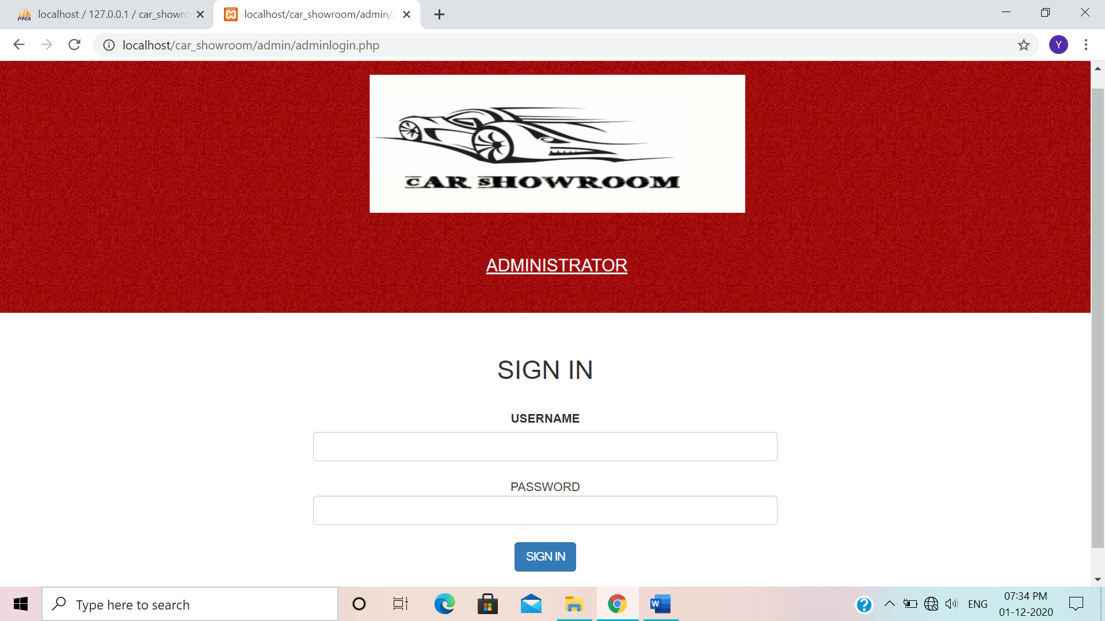

# (2) Admin Panel

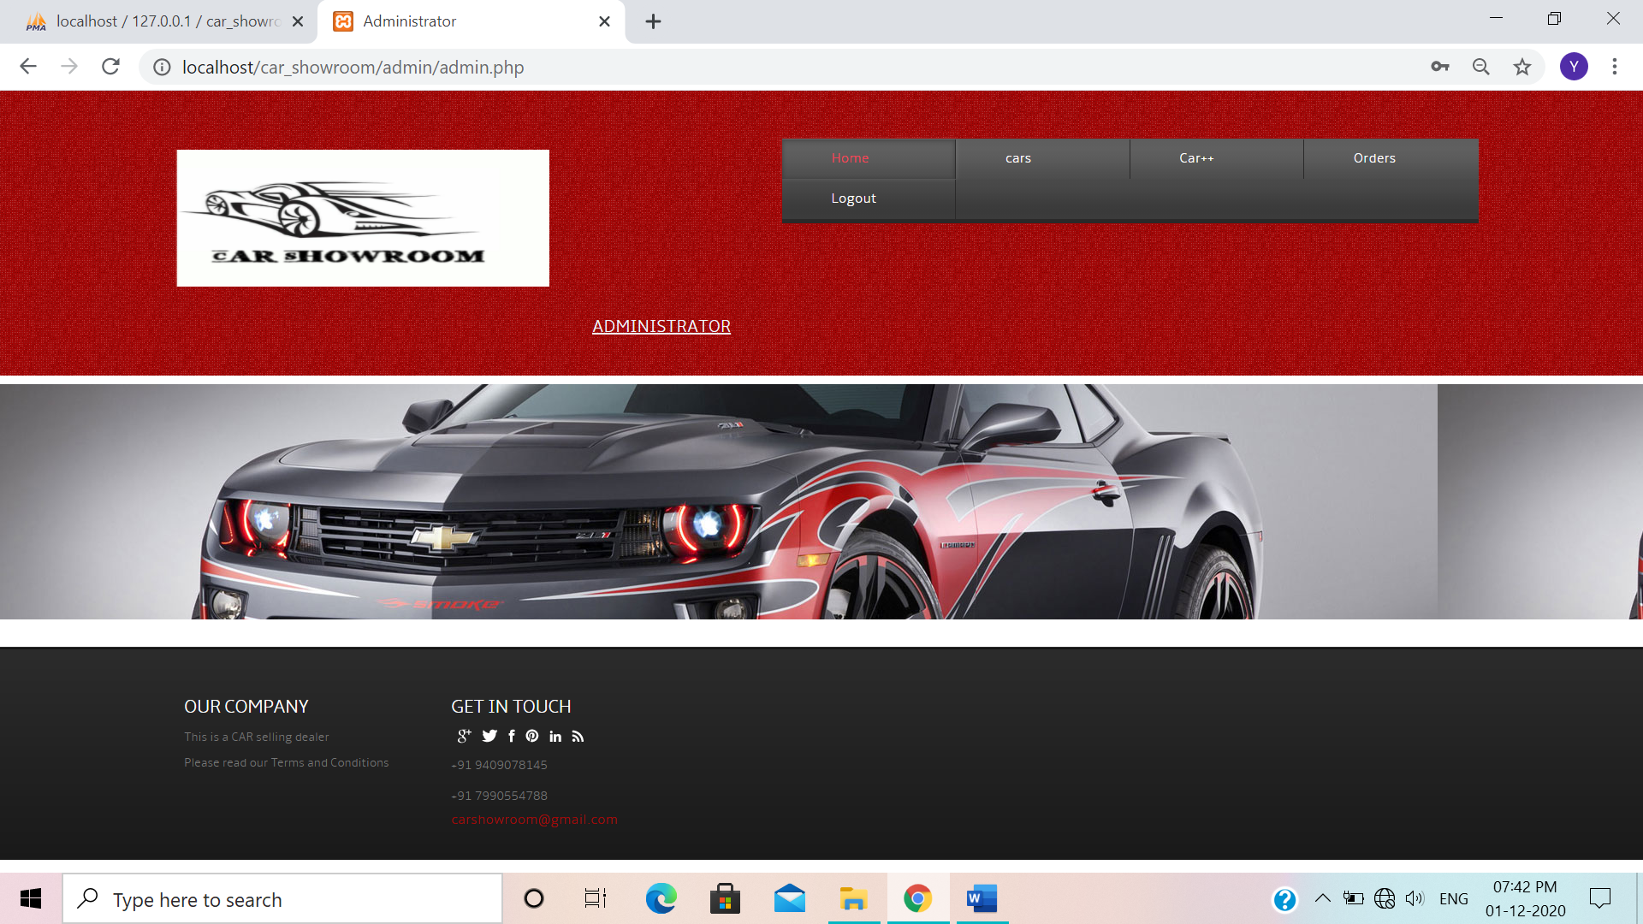

# (3) Add Car Form

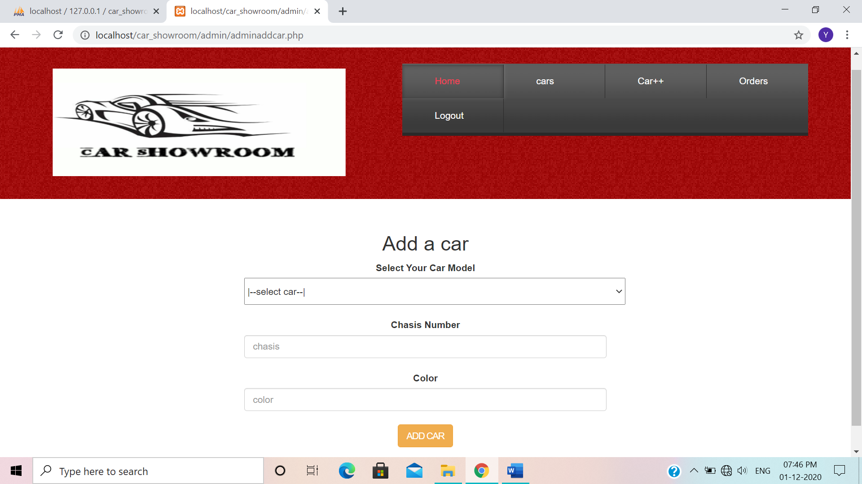

## (4) Currently Available Car

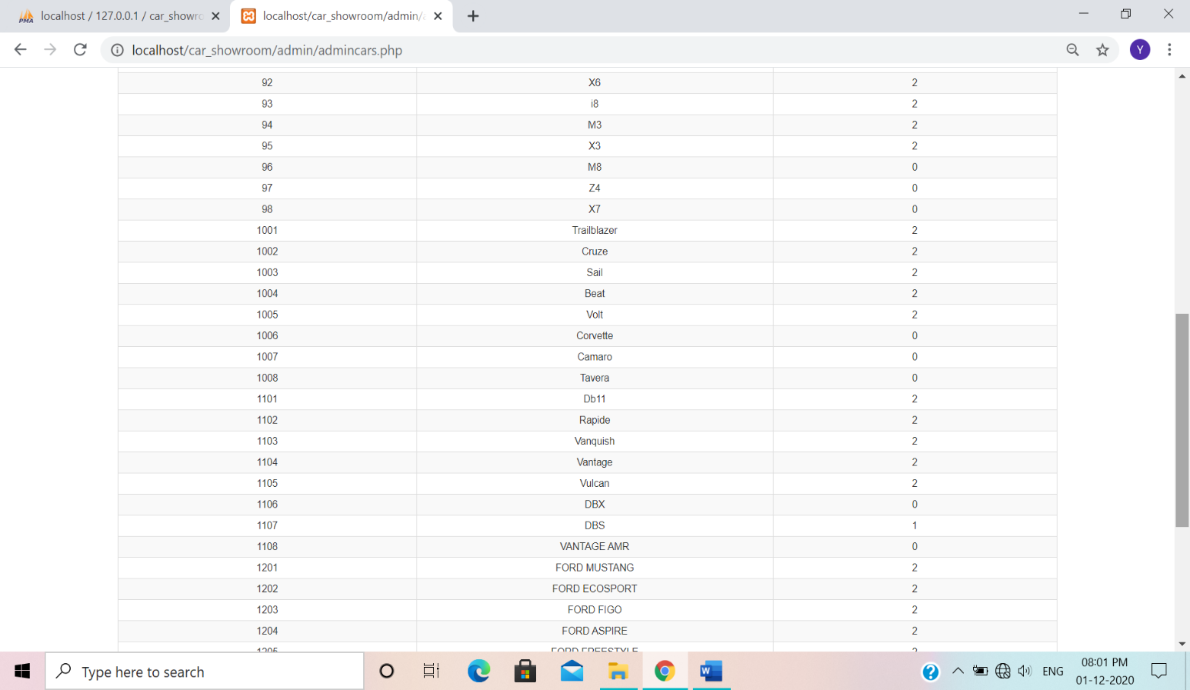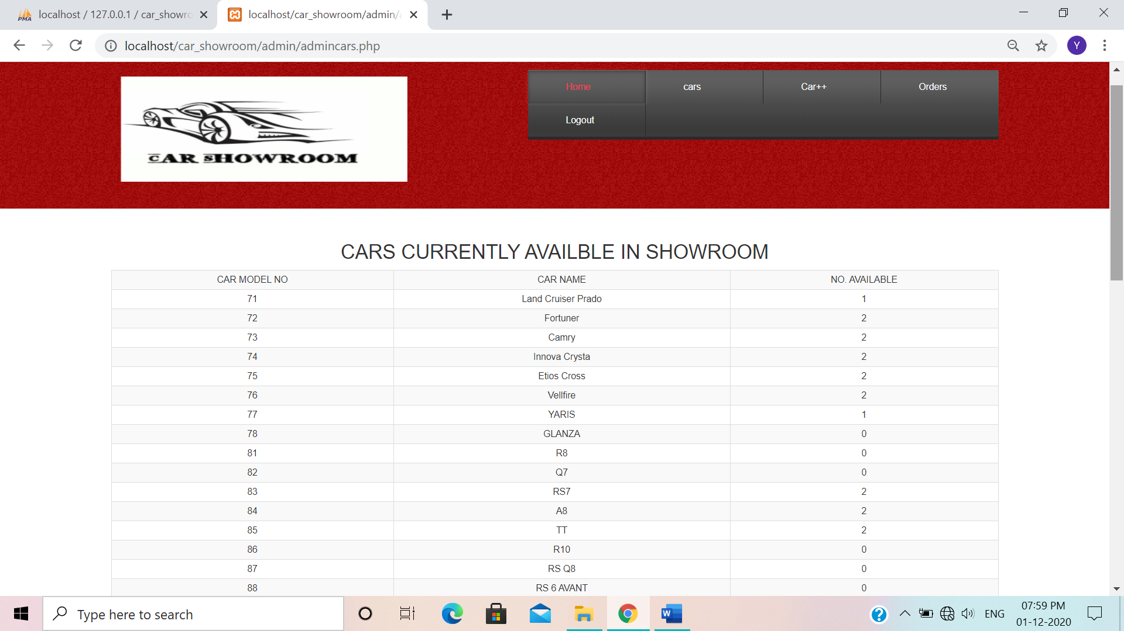

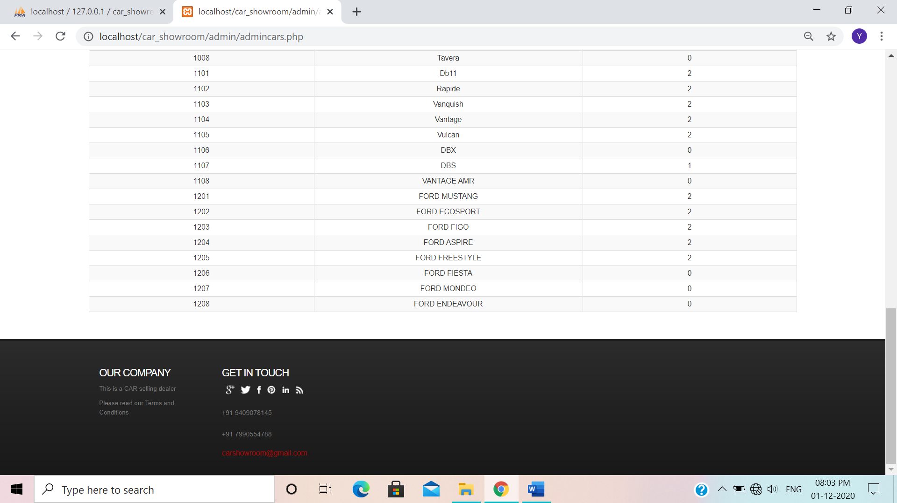

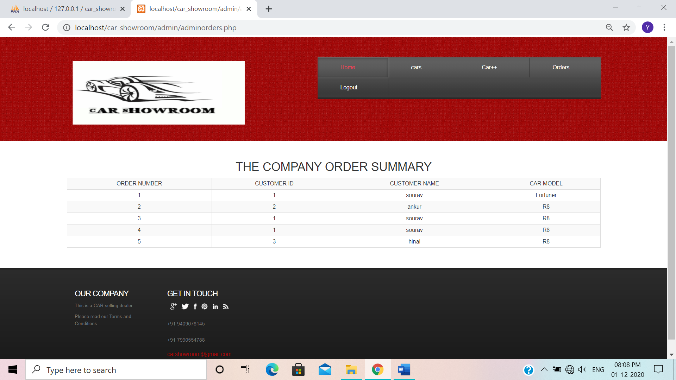(5) **Cars order**

**User side:-**

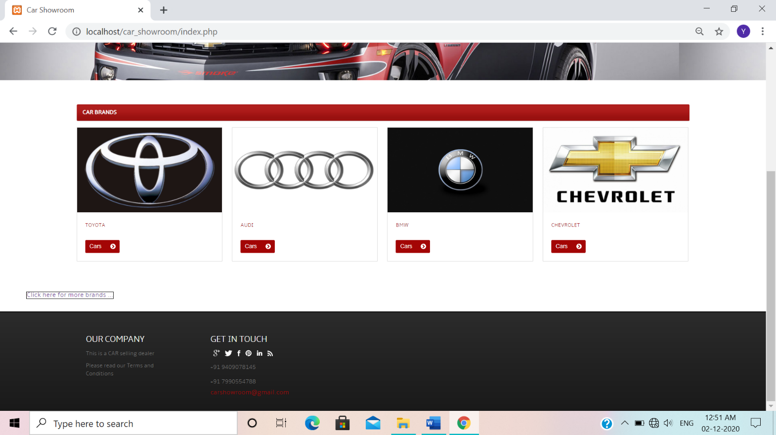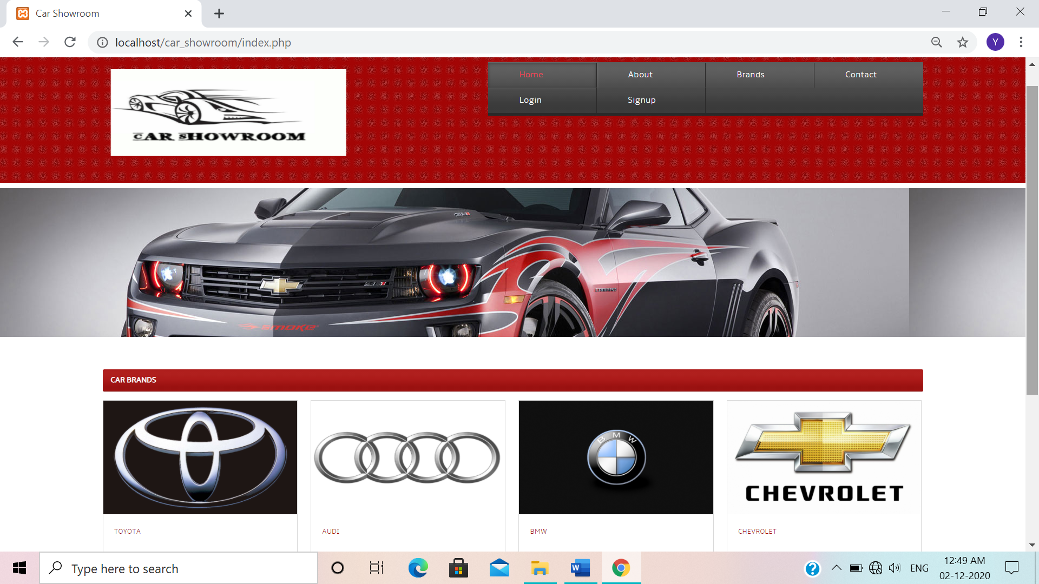(1) **Home**

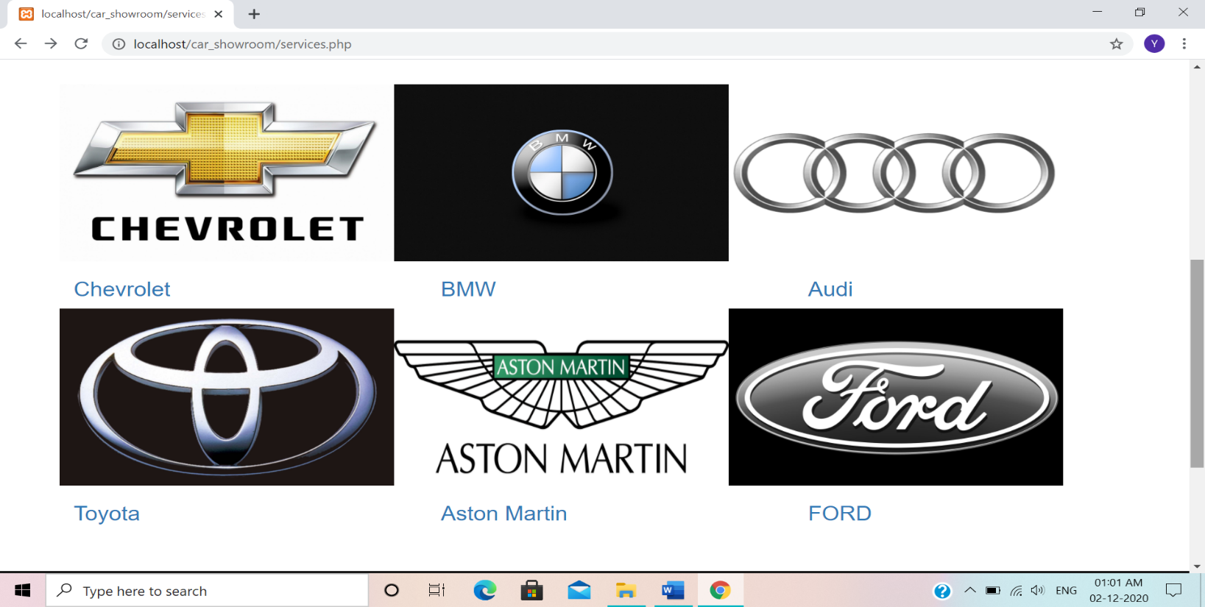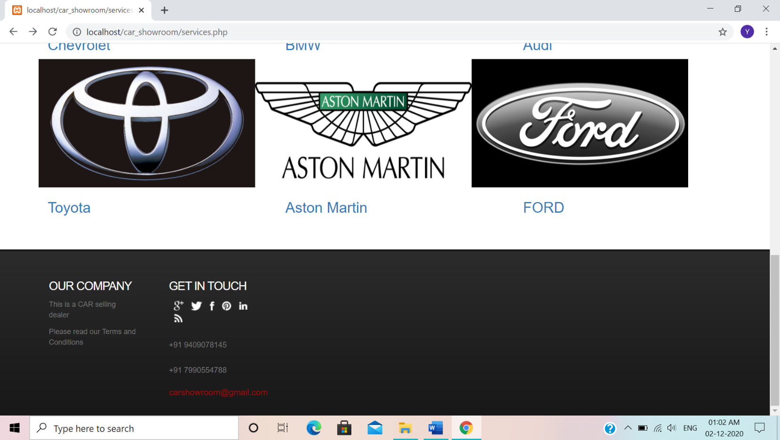(2) **Cars Brands**

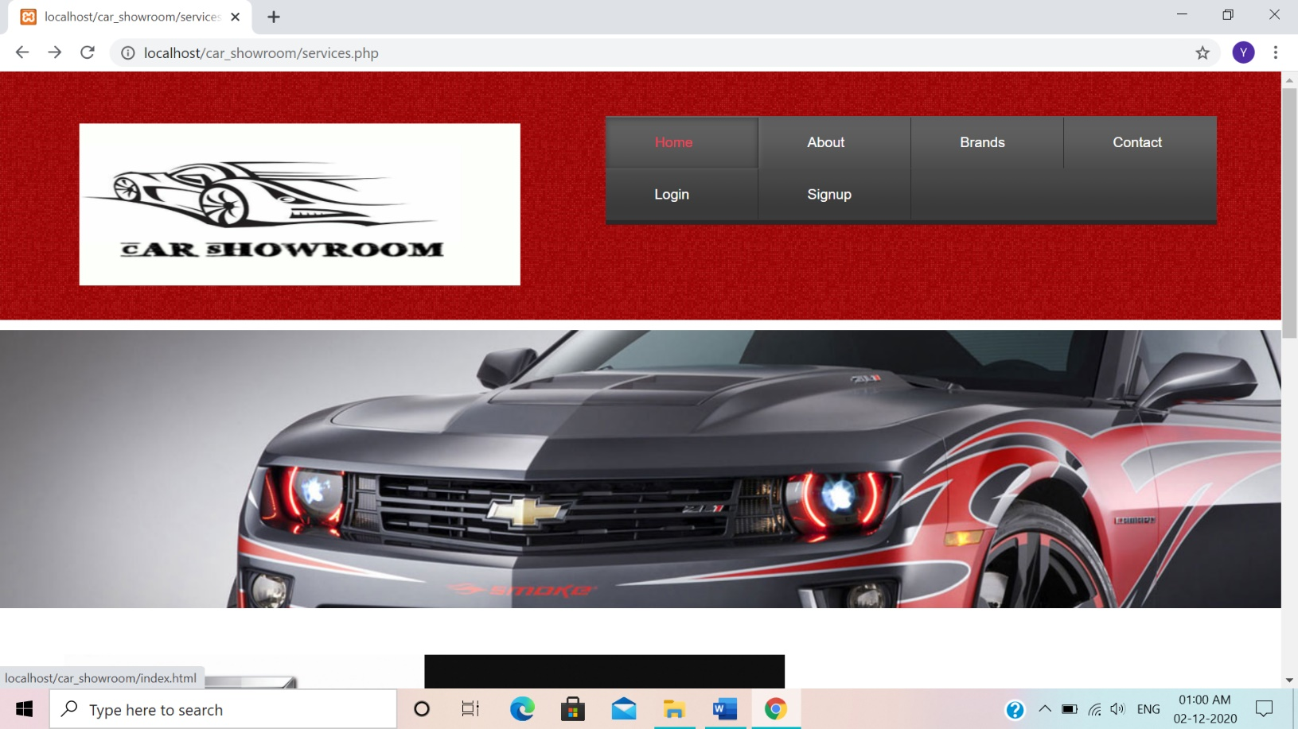

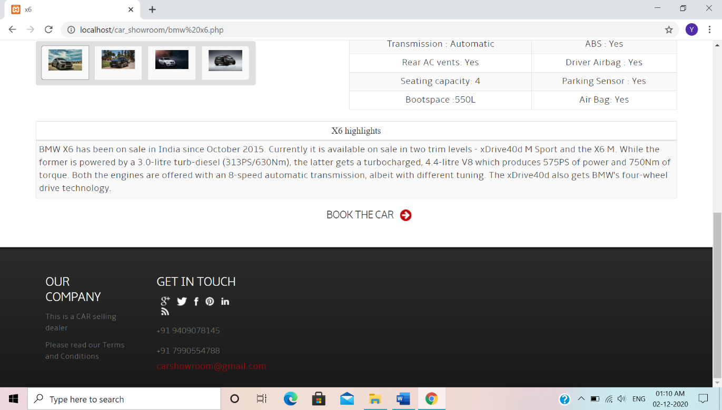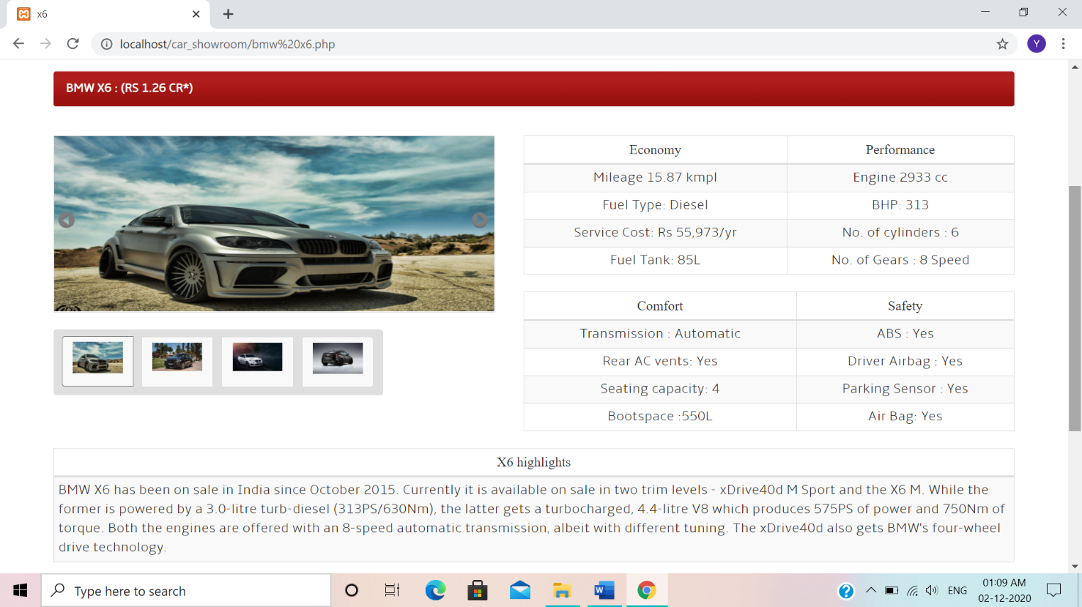(3) **Car Details**

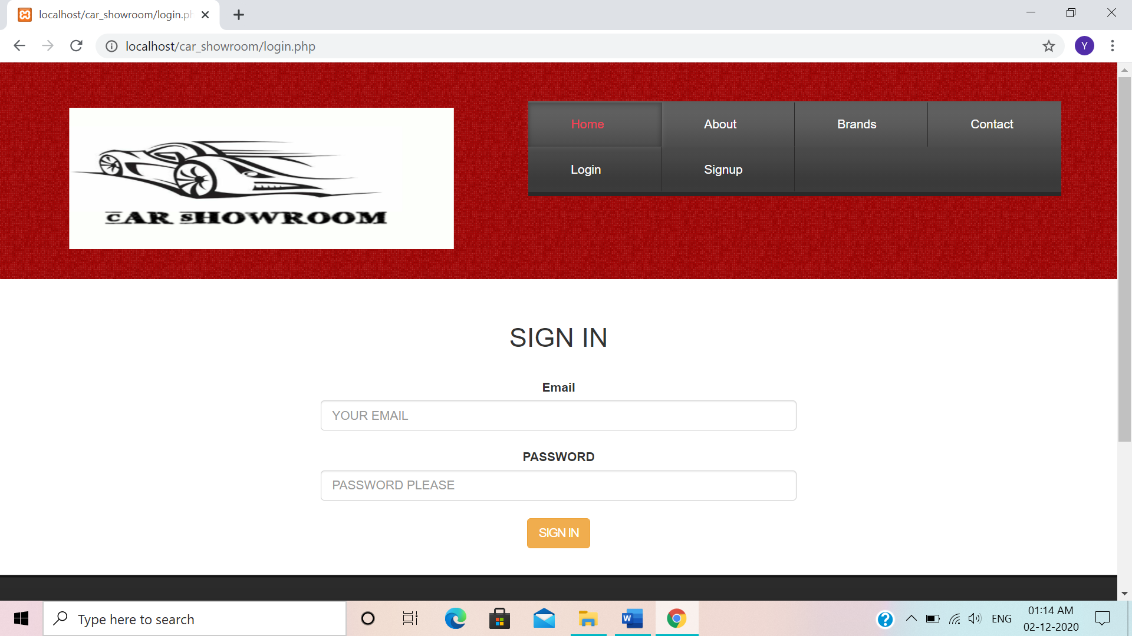(4) **login page**

(5) **Signup Page**

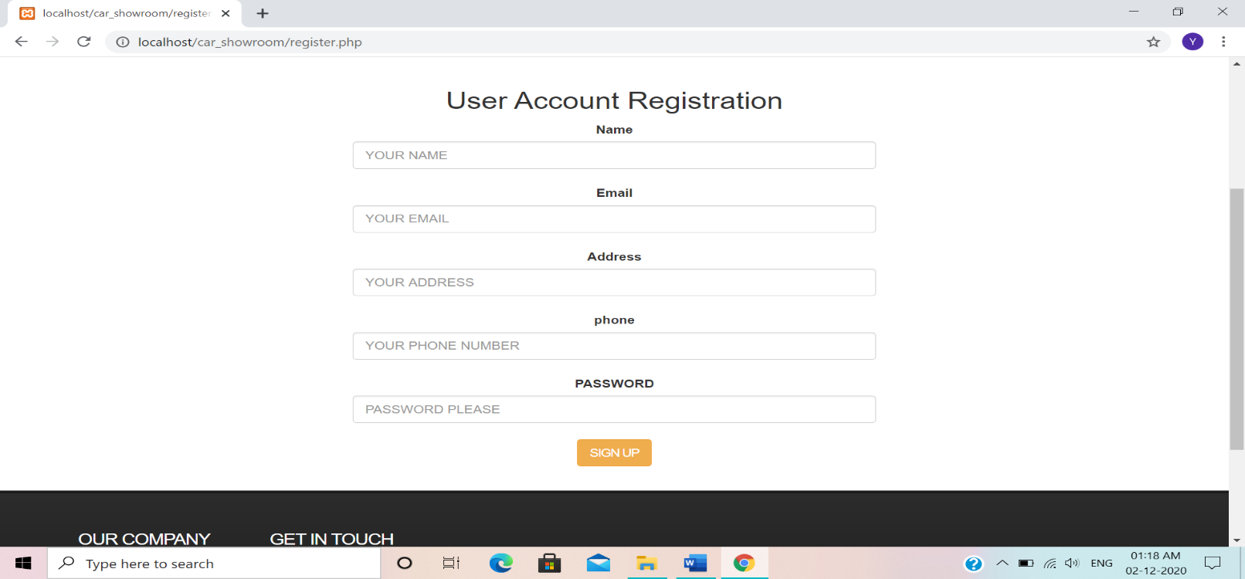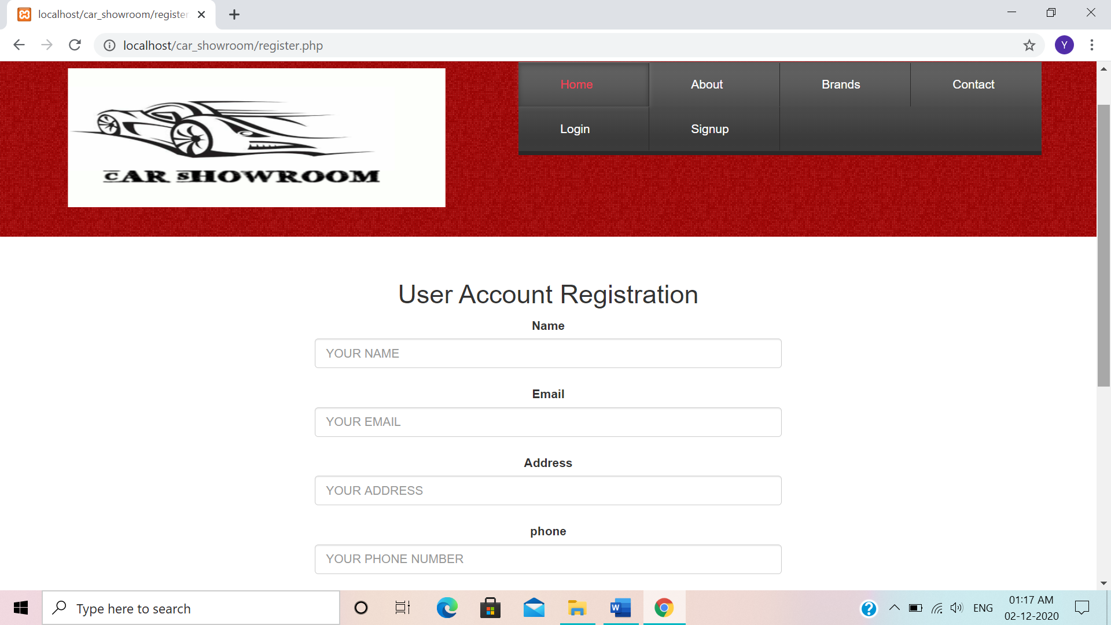

(6) **About us**

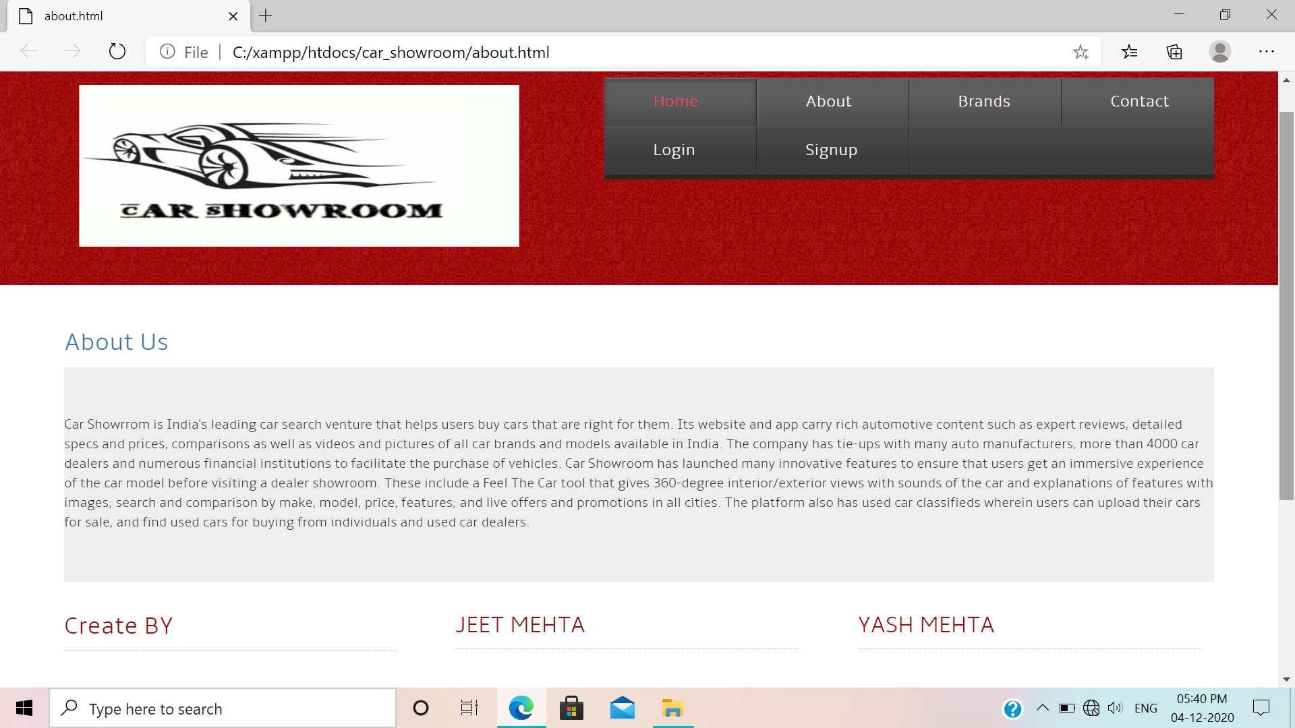

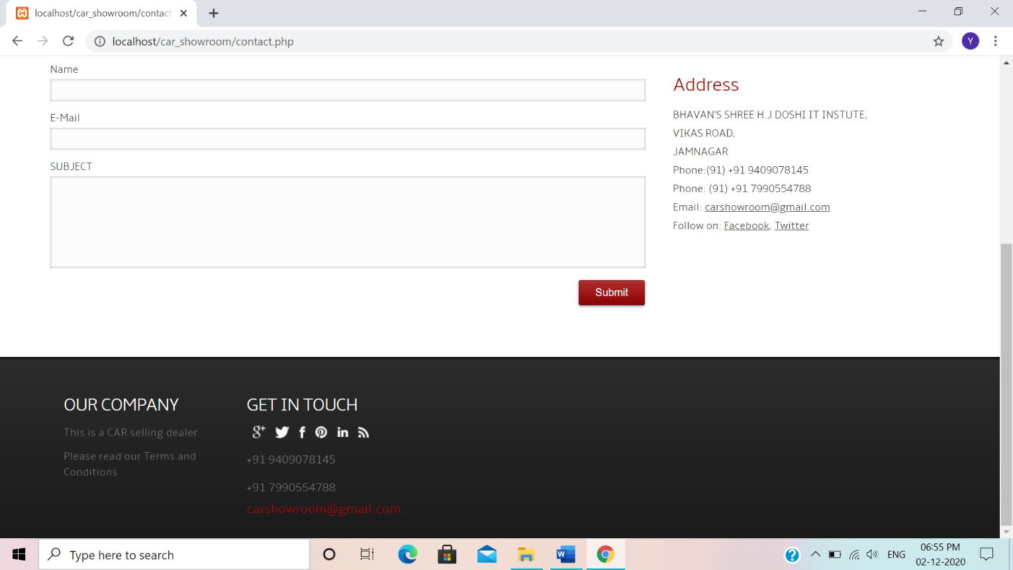(7) **Contact us**

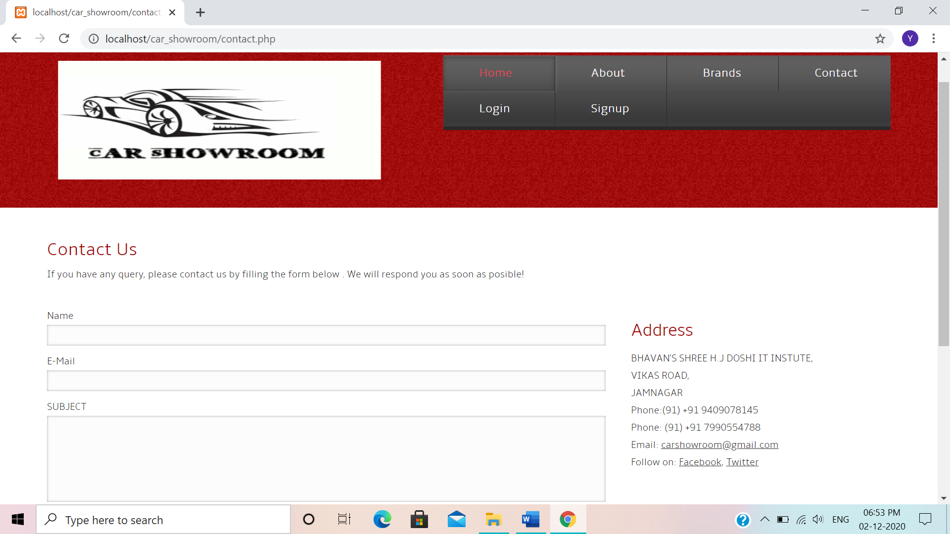

LIMITATION & FEATURES FOR FUTURE ENHANCEMENT

* **Limitation :-**

Limitation is the major part of every application and system. In every application there are certain limitations. No application or software can be there without any limitations.

Here we have done our best try to solve every limitation but some are there which we were not able to solve because of the level of our course, time limit and knowledge.

Hence our site has following limitations:-

* + Large database cannot be handled.
  + Wishlist facility is not available.
  + Data type validation – we were not able to give proper data type and data length validation due to lack of time.
  + Searching option is not possible.
* **Future Feature Enhancement:-**

In our future enhancement we will try to overcome all these above limitations.

* We will try to make it more user-friendly.
* We will solve some errors and bugs.
* We will add more features in our site.
* We will also provide some extra facilities in near future.

BIBLIOGRAPHY

* Books:
  + PHP 5.0
  + Designing using PHP
  + Web Developing using PHP
* Web Sites:
* [www.w3school.com](http://www.w3school.com)
* [www.php.net](http://www.php.net)